- Communication settings:
9600 / 8 / 1 / N

- Commands.
- Get General Information (0x01)
- Request:
Offset | Length | Value | Description
0 | 2 | 0x5A 0x5A | Packet header
2 | 1 | 0x02 | Packet payload size / 2 bytes /
3 | 1 | 0x01 | Command Id
4 | 1 | 0xFD | Checksum

- Response:
Offset | Length | Value | Description
0 | 2 | 0x5A 0x5A | Packet header
2 | 1 | byte | Packet payload size
3 | 1 | byte | Hardware version/brand ???
4 | 1 | byte | Software version 0x13 = v1.3
5 | 1 | byte | Hour 0x20 = 20h
6 | 1 | byte | Minutes 0x16 = 16m
7 | 1 | byte | Seconds 0x55 = 55s
8 | 1 | byte | Day 0x20 = 20th
9 | 1 | byte | Month 0x01 = January
10 | 1 | byte | Year 0x16 = 2016
11 | 1 | byte | 0x00 - STANDBY  0x01 - AUTO  0x02 - Timer
12 | 1 | byte | 0x00 - CH Priority  0x01 - DHW Priority  0x02 - Parallel Pumps  0x03 - Summer Mode
13 | 1 | byte | 0x00 - IDLE  0x01 - Fan Cleaning  0x02 - CLEANER  0x03 - Wait  0x04 - Loading  0x05 - HEATING  0x06 - IGNITION1  0x07 - IGNITION2  0x08 - UNFOLDING  0x09 - BURNING  0x0A - EXTINCTION
14 | 1 | byte
15 | 1 | byte
16 | 1 | Bit 0  Bit 1  Bit 2  Bit 3  Bit 4  Bit 5  Bit 6  Bit 7 | Ignition Fail  Pellet Jam
17 | 1 | byte
18 | 1 | byte
19 | 1 | byte | Tset
20 | 1 | byte | Tboiler
21 | 1 | byte | Tdhw
22 | 1 | byte
23 | 1 | byte | Flame
24 | 1 | Bit 0  Bit 1  Bit 2  Bit 3  Bit 4  Bit 5  Bit 6  Bit 7 | Heater  CH pump  BF  FF
25 | 1 | byte
26 | 1 | byte | Fan
27 | 1 | byte | 0x00 - Idle  0x01 - Suspend  0x02 - P1  0x03 - P2  0x04 - P3
28 | 1 | Bit 7 | Thermostat (1 - STOP, 0 - NORMAL)
29 | 1
30 | 1 | byte | Feeder work time in seconds
31 | 1 | byte | Checksum = sum(data) XOR 0xFF

- 0x02

- Set Burner Mode and Priority (0x03)
- Request:
Offset | Length | Value | Description
0 | 2 | 0x5A 0x5A | Packet header
2 | 1 | 0x04 | Packet payload size / 4 bytes /
3 | 1 | 0x03 | Command Id
4 | 1 | byte | Standby - 0x00  AUTO - 0x01  Timer - 0x02
5 | 1 | byte | Ch Priority - 0x00  DHW Priority - 0x01  Parallel Pumps - 0x02  Summer Mode - 0x03
6 | 1 | byte | Checksum

- Response:

- Get Burner Settings (0x04)

- 0x05

- 0x06

- Set Boiler Temperature (0x07)
- Request:
Offset | Length | Value | Description
0 | 2 | 0x5A 0x5A | Packet header
2 | 1 | 0x03 | Packet payload size / 3 bytes /
3 | 1 | 0x07 | Command Id
4 | 1 | byte | Tboiler
5 | 1 | byte | Checksum

- Response:
Offset | Length | Value | Description
0 | 2 | 0x5A 0x5A | Packet header
2 | 1 | 0x02 | Packet payload size / 2 bytes /
3 | 1 | 0x34
4 | 1 | 0xCA | Checksum

- Reset feeder counter (0x09)
- Request
Offset | Length | Value | Description
0 | 2 | 0x5A 0x5A | Packet header
2 | 1 | 0x02 | Packet payload size / 2 bytes /
3 | 1 | 0x09 | Command Id
4 | 1 | 0xF5 | Checksum

- Response
Offset | Length | Value | Description
0 | 2 | 0x5A 0x5A | Packet header
2 | 1 | 0x02 | Packet payload size / 2 bytes /
3 | 1 | 0x34
4 | 1 | 0xCA | Checksum

Case 1 - Burning at Power 2
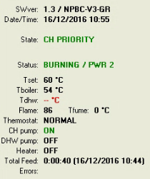
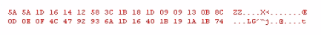

Pos 13 changed:
0x13 - 0x09 - 0000 1001

Pos 24:
0x1D - 0x08 - 0000 1000

Case 2 - Turn water pump ON
Temperature increased from 53 to 54 and the burner turned the water pump ON.
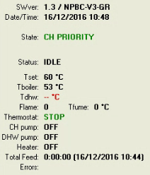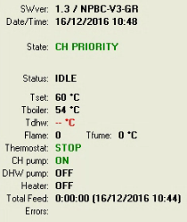
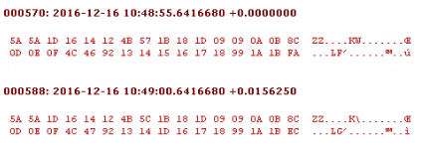

Pos 13 changed:
0x0A - 0x00 - 0000 0000

Pos 24 changed:
0x15 - 0x00 - 0000 0000
0x1D - 0x08 - 0000 1000

Case 3 - Ignition [Idle -> Fan Cleaning]
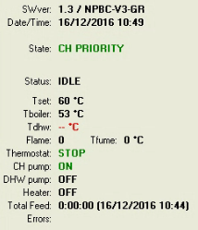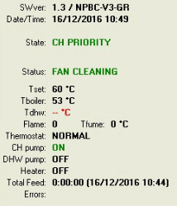
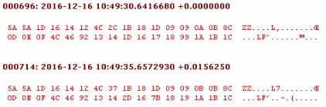

Pos 13 changed:
0x0A - 0x00 - 0000 0000
0x0B - 0x01 - 0000 0001

Pos 24 changed:
0x1D - 0x08 - 0000 1000
0x2D - 0x18 - 0001 1000

Pos 26 changed:
0x17 - 0x00 - 0000 0000 - 0
0x7B - 0x64 - 0110 0100 - 100

Pos 28 changed:
0x99 - 0x80 - 1000 0000
0x19 - 0x00 - 0000 0000

Case 4 - Ignition [Fan Cleaning -> Wait]
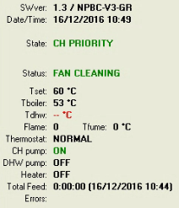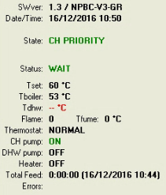
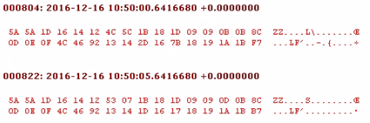

Pos 13 changed:
0x0B - 0x01 - 0000 0001
0x0D - 0x03 - 0000 0011

Pos 24 changed:
0x2D - 0x18 - 0001 1000
0x1D - 0x08 - 0000 1000

Pos 26 changed:
0x7B - 0x64 - 0110 0100 - 100
0x17 - 0x00 - 0000 0000 - 0

Case 5 - Ignition [Wait -> Loading]
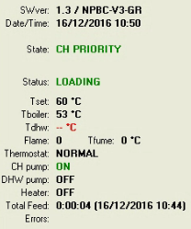
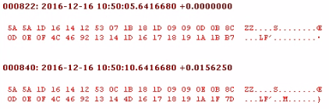

Pos 13 changed:
0x0D - 0x03 - 0000 0011
0x0E - 0x04 - 0000 0100

Pos 24 changed:
0x1D - 0x08 - 0000 1000
0x4D - 0x38 - 0011 1000

Pos 30 changed:
0x1B - 0x00 - 0000 0000
0x1F - 0x04 - 0000 0100

Case 5 - Ignition [Loading -> Ignition1]
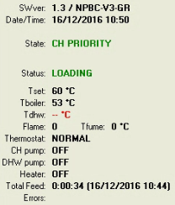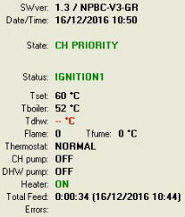
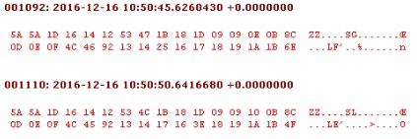

Pos 13 changed:
0x0E - 0x04 - 0000 0100
0x10 - 0x06 - 0000 0110

Pos 24 changed:
0x25 - 0x10 - 0001 0000
0x17 - 0x02 - 0000 0010

Pos 26 changed:
0x17 - 0x00 - 0000 0000 - 0
0x3E - 0x27 - 0010 0111 - 39

Case 6 - Ignition [Ignition1 -> Unfolding]
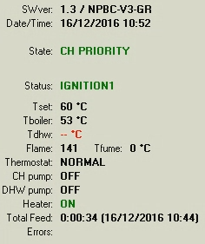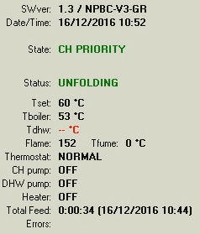
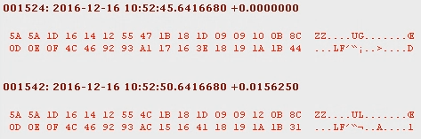

Pos 13 changed:
0x10 - 0x06 - 0000 0110
0x12 - 0x08 - 0000 1000

Pos 24 changed:
0x17 - 0x02 - 0000 0010
0x15 - 0x00 - 0000 0000

Case 7 - Ignition [Unfolding -> Power 2]
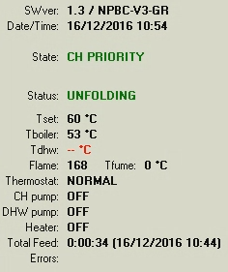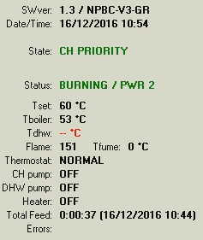
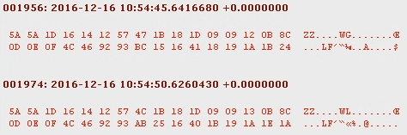

Pos 13 changed:
0x12 - 0x08 - 0000 1000
0x13 - 0x09 - 0000 1001

Pos 24 changed:
0x15 - 0x00 - 0000 0000
0x25 - 0x10 - 0001 0000

Pos 27 changed:
0x18 - 0x00 - 0000 0000
0x1B - 0x03 - 0000 0011

Pos 30 changed:
0x1B - 0x00 - 0000 0000
0x1E - 0x03 - 0000 0011

Case 8 - Ignition [Power 2 -> Power 3]
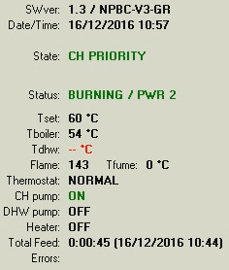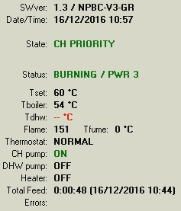
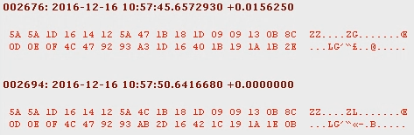

Pos 13:
0x13 - 0x09 - 0000 1001

Pos 24 changed:
0x1D - 0x08 - 0000 1000
0x2D - 0x18 - 0001 1000

Pos 27 changed:
0x1B - 0x03 - 0000 0011
0x1C - 0x04 - 0000 0100

Pos 30 changed:
0x1B - 0x00 - 0000 0000
0x1E - 0x03 - 0000 0011

Case 9 - Ignition [Change water temperature 60℃ -> 59℃]
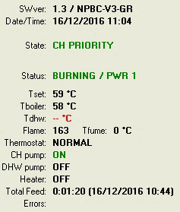
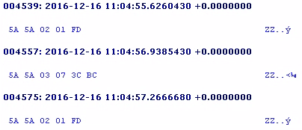
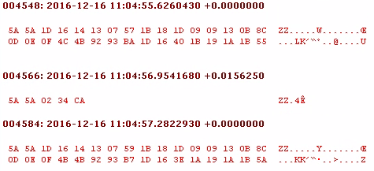

To 62℃

Date and time

16/12/2016 10:57
0x16 | 0x14 | 0x12 | 0x5A | 0x0C
0 | 1 | 2 | 3 | 4
0x16 | 0x13 | 0x10 | 0x57 | 0x08

Y | 2016 / 16 | 0x07E0 / 0x10 | 00 010000
M | 12 | 0x0C | 0000 1100
D | 16 | 0x10 | 000 10000
H | 10 | 0x0A | 000 01010
M | 57 | 0x39 | 00 111001
S | 8 | 0x08 | 00 001000

